New Client Form
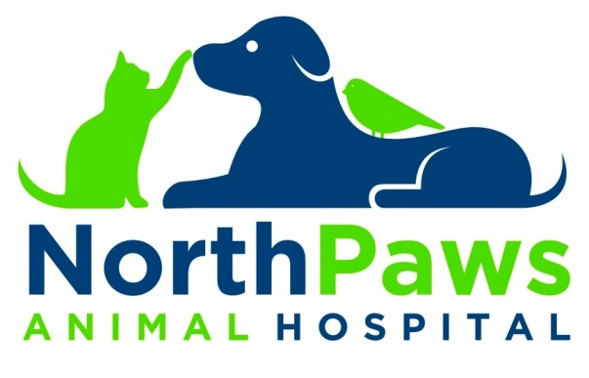
Welcome to NorthPaws Animal Hospital!
We would love to provide care to your furry and feathered family members! We know that choosing the right veterinarian is an important decision. Let us show you how our pet care is second to none.

Please help us to get to know you by providing us with some more information about you and your loved family pet(s):

Name: _________________________________________ Spouse/Co-Owner: _________________________________________
Address: _________________________________________________________________________________________________
City: ____________________________________________ State: _________________________ Zip Code:________________
Mobile Phone: ___________________________________ Work Phone: _____________________________________________
Home Phone: ___________________________________ E-Mail Address:___________________________________________

How did you become aware of our practice?

- Internet Search/Website Visit
- Newspaper
- Emergency Clinic
- Sign/ Walk-in
- Facebook
- Drive By
- Radio
- Humane Society of Wash. Co.
- Another Hospital __________________
- Employee ________________________
- Relative _________________________
- Friend ___________________________

Are you: Active or retired military? Senior Citizen? (over the age of 65)

Photograph Release
I, the undersigned, give consent for the employees of NorthPaws Animal Hospital to take photographs of my pet(s) and release rights to exhibit this work in print and electronic form including social media websites such as Facebook and Instagram.

__________________________________________________________________
Signature of Owner or Agent

