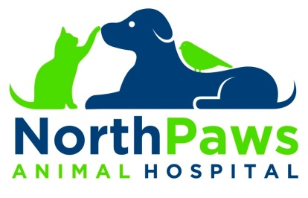

Your Pet’s Information

Pet Name: ______________________________________ Color/Markings: _______________________________________________
Breed: _________________________________________ Date of Birth or Approximate Age: _______________________________
Species (please circle): Avian Canine Feline Ferret Pocket Pet Rabbit
Sex (please circle): Female Spayed Male Neutered
Microchipped? (please circle) Yes No
Cat Patients: Environment? Indoor Only Outdoor Only Indoor/ Outdoor
Diet (what kind of food and how much?): __________________________________________________________________________
____________________________________________________________________________________________________________
Does your pet have any allergies to vaccines, medications, environmental or other allergies?
____________________________________________________________________________________________________________
Please list any previous or ongoing health issues:
____________________________________________________________________________________________________________ ____________________________________________________________________________________________________________
Please list any and all medications your pet is currently taking:
________________________________________________________________________________________________________________________________________________________________________________________________________________________
Please list any dietary restrictions:
____________________________________________________________________________________________________________
What type of Heartworm and flea and tick preventative is your pet currently using:
____________________________________________________________________________________________________________
Payment Terms
We require full payment when services are rendered. Cash and checks are always accepted. A $35 processing fee will be applied for any check that is not able to be processed by the bank. For your convenience we also accept MasterCard, Visa, Discover, and CareCredit.

NorthPaws Animal Hospital 21257 Leitersburg Pike Hagerstown, Maryland 21742 240-513-6030

